Barnham CEVC Primary School Knowledge Organiser
Year 6: Decimals |  | Knowledge Organiser
Key Vocabulary | Place Value |  |  | Fractions to Decimals
decimal place  decimal fraction  recurring decimal  equivalent fraction  tenth  sharing  partitioning  exchanging  rounding 3dp.  hundredth  thousandth  equal to  remainder  grouping  2dp.  1dp.  decimal point | 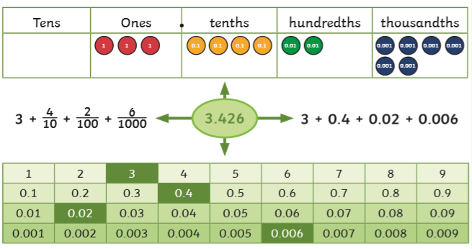 |  |  | 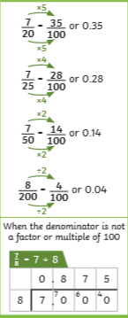
 | Dividing decimals by integers
 | 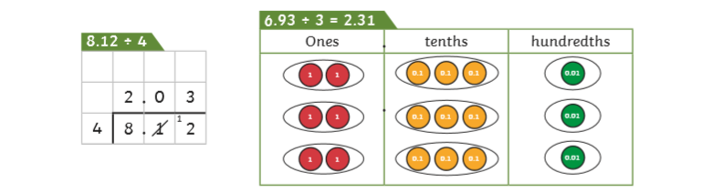
Multiplying and dividing by 10, 100 and 1000 |  |  | Decimal numbers as fractions
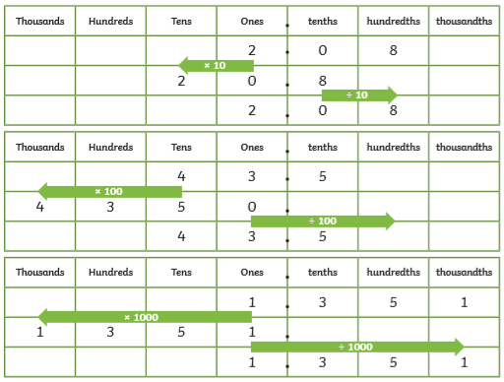 |  |  | 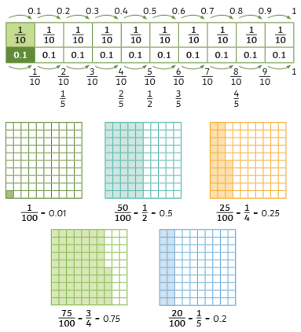  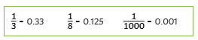
Multiplying decimals by integers


