Barnham CEVC Primary School Knowledge Organiser
Year 6: Percentages |  | Knowledge Organiser
Key Vocabulary | Equivalent fractions, Decimals and Percentages |  | Order Fractions, Decimals and Percentages.
percent (out of 100)  percentage  discount  equivalent fraction  equivalent decimal  convert  compare  order  the whole  increase  decrease  divide  multiply | 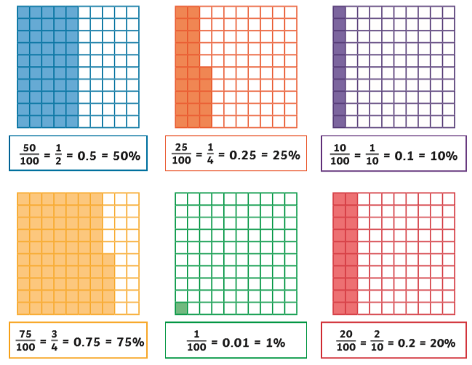  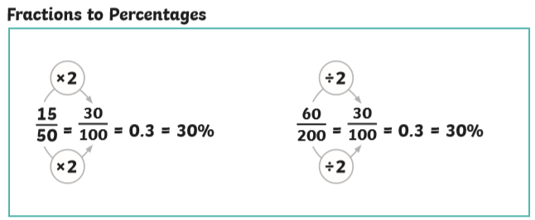 |  | 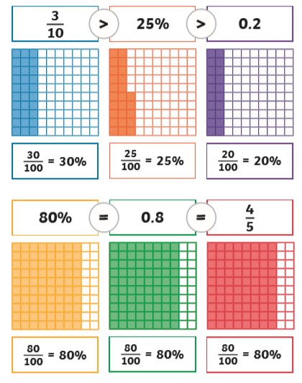
Percentages of amounts


