Barnham CEVC Primary School Knowledge Organiser
Year 6: Conversion |  | Knowledge Organiser
Key Vocabulary | Converting Mass |  |  | Converting Capacity
mass  gram  kilogram  capacity  volume  millilitre  litre  length  millimetre  centimetre  kilometre  foot  inch  ounce  pound  stone  pint  gallon  miles  days/weeks/months | 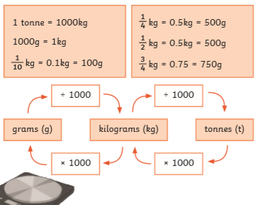 |  |  | 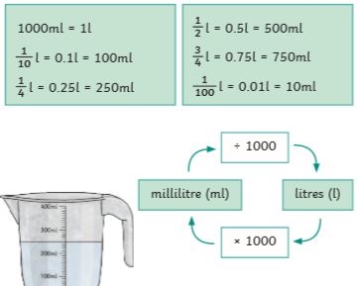
 | Converting Length
 | 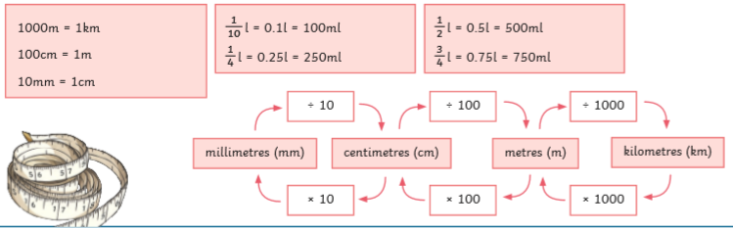
Miles to kilometres |  |  | Time
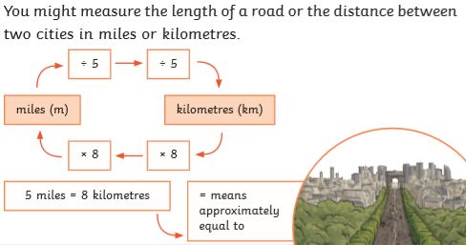 |  |  | 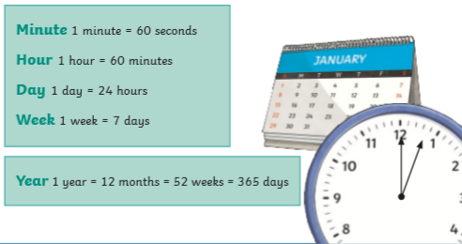
Imperial measures |  |  | Equivalent fractions, Decimals and Percentages
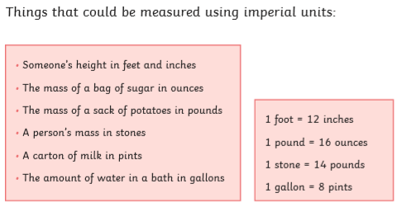 |  |  | 

