Barnham CEVC Primary School Knowledge Organiser
Year 6: Algebra |  | Knowledge Organiser
Key Vocabulary | Forming expressions |  |  | Form equations
term to term rule  variable  unknown  expression  equation  formula  one step equation  two step equation  substitution  pairs of unknowns  enumerate  function machine  number sequence | 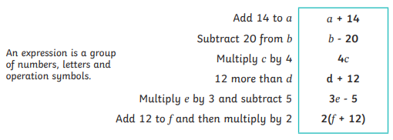 |  |  | 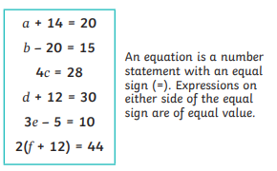
 | Linear number sequences
 | 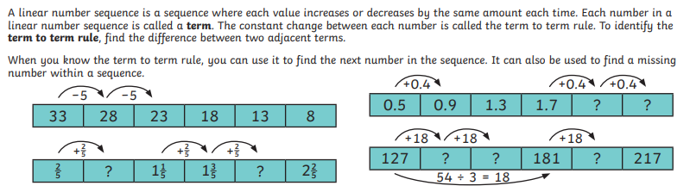
 | Formula/Formulae
 | 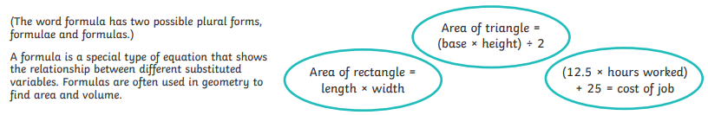
Equations with pairs of unknowns |  |  | Enumerating possibilities
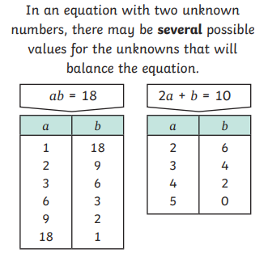 |  |  | 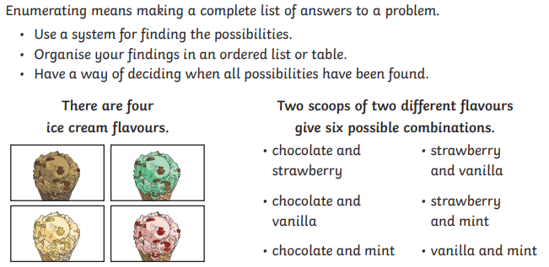
Solving one-step and two-step problems


