Barnham CEVC Primary School Knowledge Organiser
Year 6: Area, Perimeter and Volume |  | Knowledge Organiser
Key Vocabulary | Area of rectangles |  |  | Area of triangles
perimeter  distance  area  surface area  volume  cubic units  cuboid  cube  width  length  depth  rectangle  rectilinear  parallelogram  perpendicular height  base height  A = W x L  V = W x L x D | 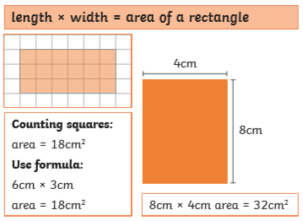 |  |  | 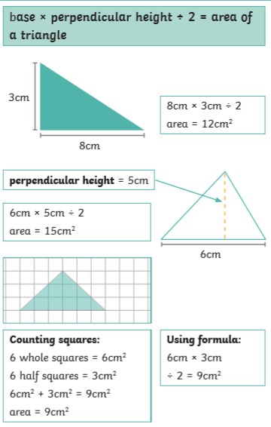
 | Peterimeter of rectangles
 | 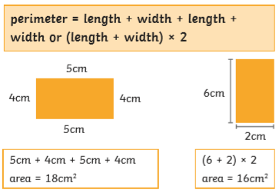
Perimeter and area |  |  | Area of parallelograms
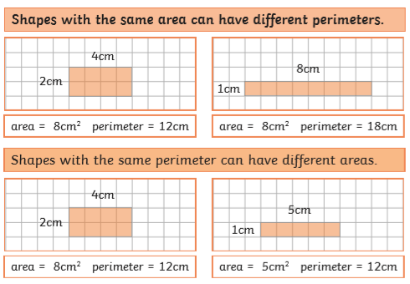 |  |  | 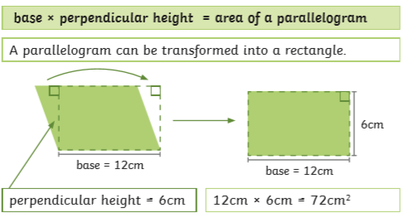
Volume – counting cubes |  |  | Volume of cuboids
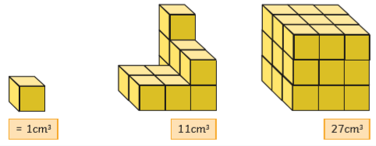 |  |  | 

