Barnham CEVC Primary School Knowledge Organiser
Year 6: Ratio |  | Knowledge Organiser
Key Vocabulary | Ratio Language |  |  | The Ratio Symbol
ratio  proportion  “for every, there are”  part  whole  scale factor  enlargement  similar shapes  length  width  perimeter | 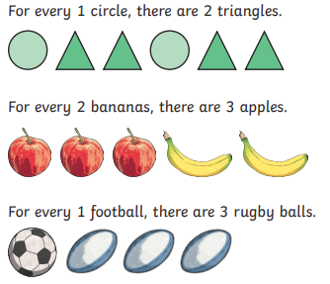 |  |  | 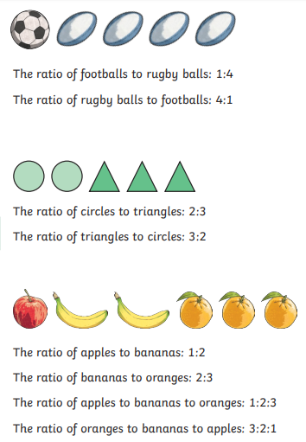
 | Ratio and Fractions
 | 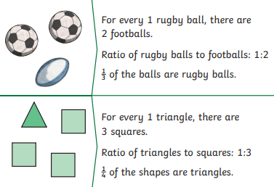
Ratio and proportion problem solving |  |  | Scale factors
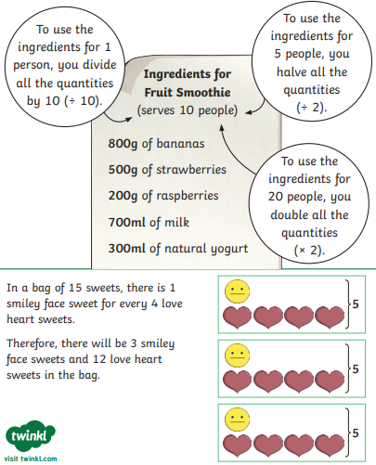 |  |  | 

