Barnham CEVC Primary School Knowledge Organiser
Year 6: Property of Shape |  | Knowledge Organiser
Key Vocabulary | Angle Types
Angle  Right angle  Acute  Obtuse  Reflex  Protractor  Horizontal  Vertical  Parallel  Perpendicular  Polygon  Regular  Irregular  2D/ 3D  Flat face  Curved face  Edge  Curved edge  Vertex/vertices  Apex  Radius  Diameter  Circumference | 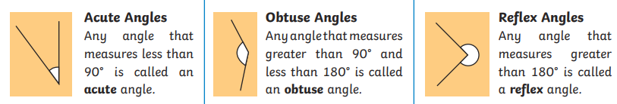
 | Calculating Angles |  |  | Angles in a Triangle
 | 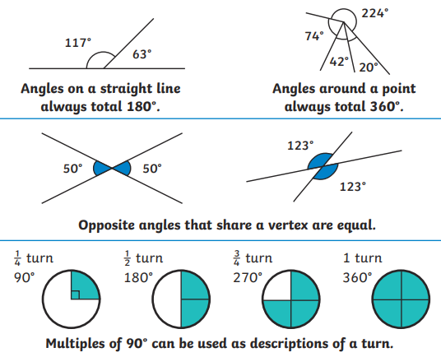 |  |  | 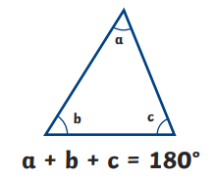
 |  |  |  | Angles in a Quadrilateral
 |  |  |  | 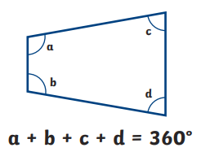
Using a protractor |  |  | Angles in Regular Polygons
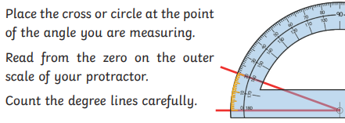 |  |  | 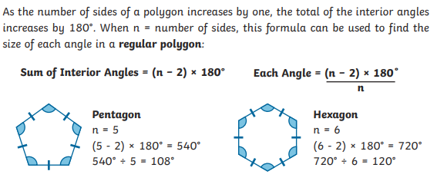
Parts of a circle |  |  | Properties of 3D Shapes
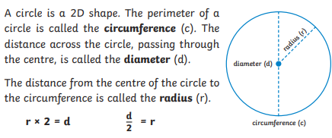 |  |  | 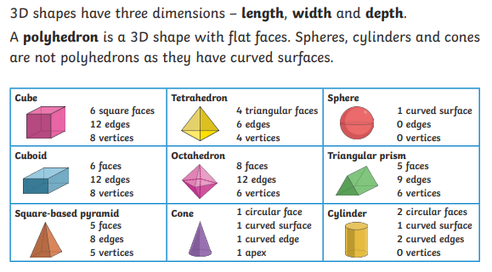
Nets of 3D Shapes


