Barnham CEVC Primary School Knowledge Organiser
Year 6: Statistics |  | Knowledge Organiser
Key Vocabulary | Interpreting Data |  |  | Pie Charts
bar chart  pictogram  frequency table  tally chart  pie chart  discrete data  continuous data  line graph  sum  difference  comparison  interpret  mean average | 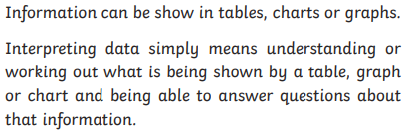 |  |  | 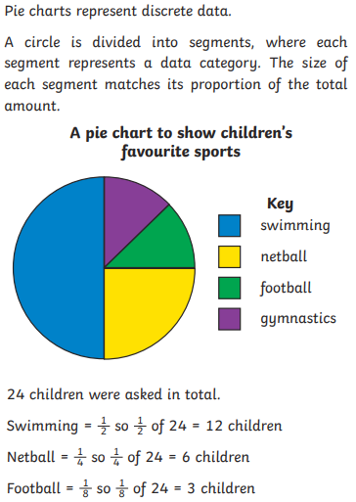
 | Line Graph
 | 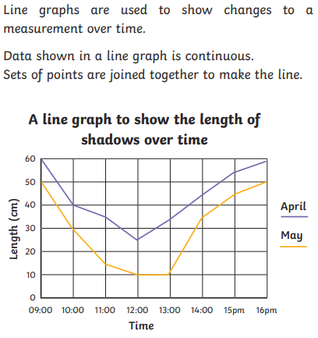
Bar Chart |  |  | Pictogram
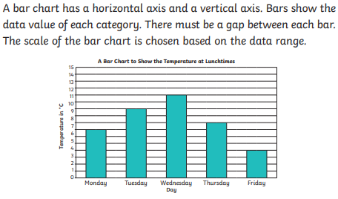 |  |  | 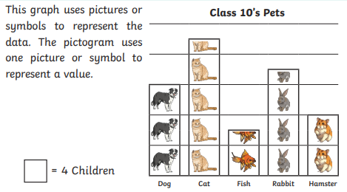
Frequency Table |  |  | Mean Average
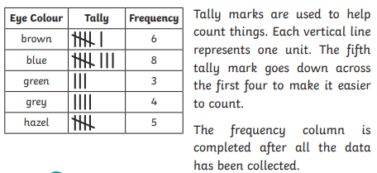 |  |  | 

