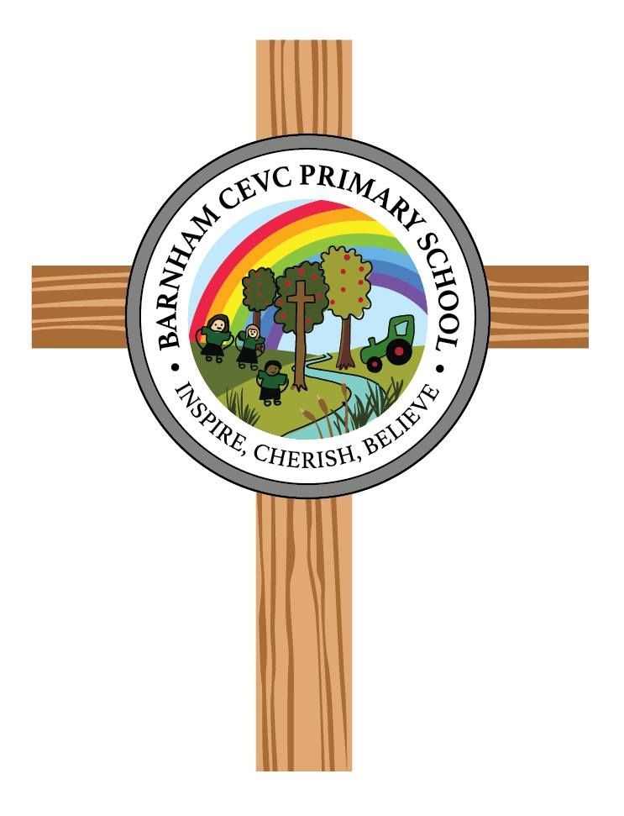
Barnham CEVC Primary School

RELIGIOUS EDUCATION (RE) POLICY
Intent
Barnham CEVC Primary school is committed to enabling children to flourish and achieve their fullest potential through providing opportunities to be ‘the best they can be for themselves, for others and for God’s world’. We want all children to feel respected and valued as contributors to our school family.

Religious Education is part of the basic educational entitlement for all pupils. It is statutory for ALL schools but is not part of the National Curriculum.

It is widely acknowledged that the primary purpose of RE is to develop ‘religious literacy’, a skill much needed given the vast range of religious and secular worldviews in our global society. Religious literacy may be defined as the ability to ‘hold balanced and well-informed conversations about religion and belief’

Following the new agreed syllabus (2023) for Suffolk at Barnham means that we will aim to develop religiously literate citizens who:

• possess rich knowledge of the beliefs of different religions and worldviews, including how these may be differently interpreted or change over time.

• recognise that the ‘lived reality’ of different religions and worldviews is complex and diverse, and that generalities and assumptions must be treated with care.

• contribute constructively to debate about religious questions and shared human concerns, using their understanding of religion and belief

In order to achieve these central aims, our RE lessons will seek to:
- provoke challenging questions about the ultimate meaning and purpose of life, beliefs about God, the nature of reality, issues of right and wrong, and what it means to be human.
- develop pupils’ understanding of the beliefs and teachings of Christianity and other principal religions and worldviews in Britain, and their influence on the lives and decisions of individuals, families, and communities.
- stimulate pupils’ curiosity about the diversity and impact of worldviews, religions, beliefs, values and traditions, and develop their ability to learn from these.
- challenge pupils to reflect on, analyse, interpret and evaluate issues of truth, belief, faith and ethics, and to communicate their own ideas and responses clearly, while being sensitive to the worldviews of others.
- encourage pupils to develop their own sense of identity and belonging, and clarify their own worldview, enabling them to flourish individually as responsible citizens in a plural society, and in a wider global community.
- prepare pupils for adult life and employment, encouraging sensitivity to those whose beliefs differ, and seeking to combat prejudice and negative discrimination.

Ensuring a balanced approach to Religious Education
At Barnham, we aim to ensure we have a balanced approach to RE and therefore as recommended by the new syllabus, we present it as a blend of these academic disciplines:
Theology
Philosophy
Human and Social Science
When these are applied to learning in RE, these provide a balanced picture of religions and worldviews, which in turn leads to better religious literacy.
Theology in RE involves enquiry into:
• Key beliefs / concepts of a religion or worldview, both distinctive and shared
• Sources of authority for religious beliefs e.g. sacred texts, religious leaders, divine revelation
• Particular beliefs about God, humanity, life, and the nature of an after-life
• Differences in interpretation of key beliefs and changes in religious belief across time / culture

Human and Social Science in RE involves exploration of:
• Different customs, celebrations and rituals based on religious and secular beliefs
• The influence of sacred texts and religious leaders on communities
• Diverse interpretations of religious practices in different societies locally and globally, and at different times
• Moral, ethical and practical lifestyle choices based on secular or religious worldviews

Philosophy in RE involves engagement with:
• Ultimate questions of truth, morality, purpose and meaning in life
• Questions arising from religious and secular standpoints, texts or customs
• Conflicting answers offered by religious and non-religious groups and individuals
• Changes in questions / answers over time and across societies

Developing Positive Attitudes in Religious Education
Acquiring knowledge of religious and secular worldviews is central to religious education, but it is also vital that pupils develop positive attitudes if they are to ‘hold balanced and well-informed conversations about religion and belief’. Pupils also need practice in responding positively to those, in class and in wider society, who have differing views and backgrounds. Teachers in every key stage should encourage, model and actively seek opportunities to develop the following:

Self-awareness
• feeling confident about sharing their own beliefs and identity without fear of ridicule or embarrassment
• developing a realistic, positive sense of their own religious, moral and spiritual ideas
• recognising their uniqueness and self-worth as human beings
• becoming increasingly sensitive to the impact of their ideas and behaviour on other people

Respect for all
• seeing the need to listen and be sensitive to others’ feelings
• being willing to learn from others, even if their views differ
• being ready to value difference and diversity for the common good
• appreciating that some views are not inclusive and that this raises issues for individuals and society
• being prepared to recognise and acknowledge their own bias

Open-mindedness
• being willing to learn and gain new understanding
• being able to engage respectfully in debate about religious, moral or spiritual questions
• learning to disagree reasonably without belittling or abusing others
• going beyond surface impressions
• distinguishing between opinions, viewpoints and beliefs

Appreciation and wonder
• appreciating, and continuing to develop a sense of wonder at, the world in which they live
• recognising that knowledge is bounded by mystery
• developing their imagination and curiosity
• developing a deep desire to ask, and respond to, questions of meaning and purpose

We teach RE well to enable our children to be good citizens of a multicultural and diverse society.

Implementation

Legal Requirements, Provision and Aims
All schools and academies in England are legally required to provide Religious Education (RE) to all pupils. The National Curriculum states that every state-funded school must offer a curriculum which is broad and balanced, and which promotes the spiritual, moral, cultural, mental and physical development of pupils, and prepares pupils at the school for the opportunities, responsibilities and experiences of later life. All schools must publish their curriculum by subject and academic year online.
Our school is a Church of England Voluntary Controlled School and the provision of RE must be in accordance with the Locally Agreed Syllabus for Suffolk and is informed by the National Society for Education’s Statement of Entitlement for Religious Education.
RE in all Church of England schools is seen as having equal standing with the core subjects. In this school, we provide a rich and varied RE curriculum, enabling learners to acquire both a thorough knowledge and understanding of the Christian faith, and other faiths and worldviews.
The primary aim of the subject may be described as promoting religious literacy. The broad aims of RE are set out in the Church of England’s Statement of Entitlement.

Children at Barnham school will access a minimum of the time allowance allocated for RE which is EYFS- Equivalent of 30 minutes a week
KS1 – 36 hours per year which equates to approximately 55 minutes week.
KS2– 45 hours per year which equates to approximately 70 minutes per week.

Our Long-Term Plans have been drawn up together with advice from our local SACRE, RE Advisor and RE Subject Leaders county-wide.

We teach a balance of religions across all year groups and ensure there is Christianity in each year group and that no other religion is taught more in a year group than Christianity.

Our personalised two-year rolling programme is an efficient way of organising the different religions and introducing them gradually. This also works well at Barnham where children are in mixed-age classes. Teaching in this way also allows staff an opportunity to do joint planning, moderate work and share resources more effectively.

Throughout their RE education at Barnham our children will experience and benefit from a cumulative curriculum approach, their knowledge and skills will build on and expand previous learning.

RE is mostly taught in weekly RE sessions across the school although on occasions may be taught as a block unit of work. We follow the Suffolk agreed syllabus for RE and use the multi-faith scheme called 'The Emmanuel Project' to support our delivery of the learning themes and key concepts for all major world faiths.

This scheme of work was published by the Diocese of St Edmundsbury and Ipswich and our RE Subject Leader was involved in some of the writing and piloting of these programmes. These units engage the children in creative, exciting activities with a high level of challenge.

These units allow the following religions to be studied:
Christianity, Islam, Judaism, Hinduism, Sikhism and Humanism

Other religious traditions (e.g. Baha’i, Jainism, Zoroastrianism), may be included once in each key stage, especially where represented locally and as opportunities arise but these are not a requirement.

There are no presumptions made as to the religious backgrounds and beliefs and values of the children and the staff. We value the religious background of all members of the school community and hope that this will encourage individuals to share their own experiences with others freely.

All religions and their communities are treated with respect and sensitivity and we value the links, which are, and can be made between home, school, and a faith community.
We intend to teach our RE Curriculum in a way that:
- Is open, objective and enquiry based, it does not seek to urge religious beliefs on young people, nor compromise the integrity of their own religious position by promoting one tradition over another.
- Endeavours to promote a positive attitude toward people, respecting their right to hold different beliefs from their own.
- Promotes the values and attitudes necessary for citizenship in a multi-faith and multi-racial society through developing understanding of, respect for, and dialogue with people of different beliefs, practices, races and cultures.
- Celebrates the similarities and differences of a breadth of religions and cultures; respecting and valuing these for the common good.
- Is not the same as collective worship, which has its own place in the educational life of the school – together with RE it contributes to an informed, reflective, compassionate and caring school and community.
- Promotes community cohesion through linking with partner schools, faith schools, religious groups in our community and the wider community and places of worship.

Here is the cycle of learning of RE at Barnham:

The Cycle of Learning of RE at Barnham CEVC Primary School
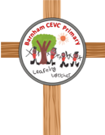

In addition to this:
- Children will explore some big questions alongside this cycle of learning.
- Key vocabulary will be selected from each Emmanuel Project unit, revisited and extended as children progress through the year groups
- Explicit links between St Gregory’s Church, Barnham and other local churches will be made where appropriate to support the teaching of Christianity
- Links will also be explored with people and places connected to other faiths
- Access to religious artefacts and faith books in particular The Bible will be available.
Big Questions
As mentioned above, the new syllabus asks children to reflect on some big questions as part of their learning in RE.
Opportunities to talk about these are provided through RE lessons and beyond.

The table below shows the questions and when they will be explored:

Class / Year Group | Big Questions covered within the two year rolling programme
Reception and Year 1 | What does the word God mean?  Is it always easy to help someone?  What is really important to do?  Why are some people revered?  Does everyone need some help?  Is everyone of us special?
Year 1 and Year 2 | Is it important to belong?  Why do people celebrate?  Should everyone learn to pray?  What do people believe is important?  Who is it right to follow?  Can books and stories be good teachers?
Year 3 and Year 4 | Do beliefs make any difference to someone’s life?  What beliefs drive people to make a difference in the world?  What makes some people an inspiration to others?  What beliefs bind a community together?
Year 5 and Year 6 | Where do people look for answers to life and living?  Are some things more sacred than others?  Why are there so many different ideas about God?  What are the best ways to think about death and dying?

You may find these questions in the classrooms with some thoughts recorded on post-it notes as children explore and reflect on these questions throughout the school year.

RE in EYFS

The most relevant statements for RE are taken from the following areas of learning:
- Personal, Social and Emotional Development
- Understanding the World

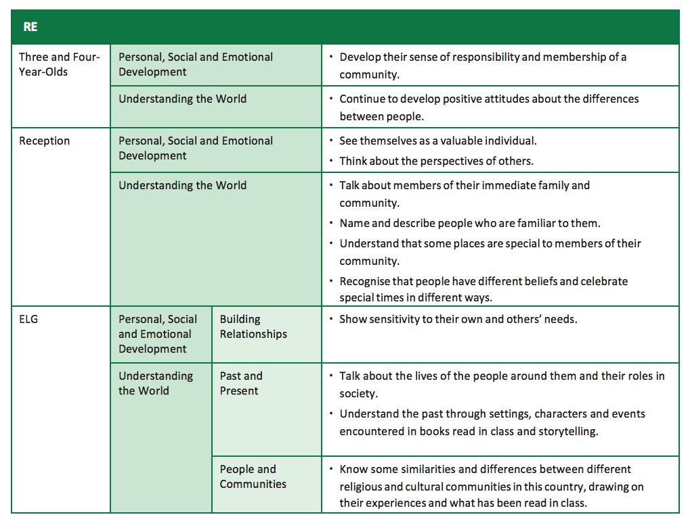
We will endeavour to make learning in RE accessible for children in EYFS by:
• Careful phrasing of tasks and questions helps.
• Do things in the context of stories and situations. Role play is helpful.
• Encourage imagination and empathy, as these are crucial to moral and spiritual development. Ask questions about characters; how do you think he feels? Insist on a few seconds thinking time before a response
• Ask questions that make children think about their own responses.
• Encourage the use of books in RE.

RE Enrichment

Special Days & Events
Our RE curriculum is enriched through additional ‘RE days and projects’ throughout the school year. This could be through a ‘Light Day’ as an alternative to Halloween, perhaps a day exploring different religious festival or even a week celebrating Interfaith.
These enrichment opportunities vary for the children each year to keep interest and engagement high and learning opportunities varied.

RE Projects
Sometimes we will challenge learners with various projects that might be linked to their learning in RE lessons or linked to a particular season, festival or time in the church year.
Again, these projects vary over the school years but we usually have an advent and lent project every year.
These are always popular and well received by learners and this in turn keeps RE a high-profile curriculum subject at Barnham.

Visits to Places of Worship
We believe that educational visits to places of worship are an important aspect of learning in the RE curriculum as they give children an opportunity to add meaning and significance to their classroom learning. They also encourage children to challenge misconceptions and stereotypes through experience and asking questions within a safe and controlled environment.
Therefore, we will aim to offer regular trips to places of worship where possible.

During their school career at Barnham pupils will also have the opportunity to visit other Christian places of worship locally to enhance their knowledge of Christianity and the wider ‘church’.

Visitors
As much as visits out are important, we also want to welcome visitors in when appropriate throughout the RE curriculum to share their personal faith and experiences with the children. This also enables our children to see their learning into a life context and allows pupils to reflect, question and challenge respectfully.

Recording & Evidencing work in RE
From September 2023, all RE Learning will be recorded in class scrapbooks which all children will contribute to and have examples of their work in. Classes that complete the same unit of work will have a shared scrapbook. Most of the feedback will be given verbally as these books are made with the class and there will be less formal written marking in RE.
Progress should be clearly evidenced as we will complete an initial assessment piece of work at the start of the book and a final assessment piece at the end. This will usually involve the class being given the enquiry question for that unit and being asked to share what they know already and what they want to learn as the initial-assessment task.
When the unit has been taught fully, it will be expected that children can fully answer the enquiry question and explain the learning they have done. This is known as the end of unit assessment.
Teachers may also ask the children to rate their learning at the beginning of a unit and then again at the end. They colour code themselves against the enquiry question for that particular unit of work, this will usually be evidenced using a photograph as it is easy to visually see the progress that has been made. These are the colours:
Red – I can’t answer the question
Orange – I know what the question is asking. I can give a possible answer with an example
Green – I can answer the question with several examples from my lessons and research
Blue – I could coach someone else to answer the question. I can make interesting links across other subjects and faiths.

We acknowledge that evidence in RE doesn’t always have to be written and although we encourage high expectations in all subject and the development of key literacy skills we want to use a wide range of communication and evidence of work in RE. Photographic or video evidence of dance, drama or role play can be used and can be stuck into scrapbooks or kept electronically.

Monitoring and Assessment
RE is monitored as a core subject and assessment data is also collected at the same time as with other core subjects. We use Insight for this purpose. Parents are updated 3 times a year on their child’s progress and attainment in this subject.
Colours and Symbols in RE
In our teaching and learning will ‘colour-code’ the different religions to enable the children to make sense of their learning by adding an associated colour. We will also have a symbol for each religion too.
The table below shows these, teachers will use these colours and symbols in their planning and presentation slides for example.
Christianity | Yellow representing Jesus the Light of the world. | 
Judaism | Blue is an important colour often used in Judaism, it is often used to decorate their homes. | 
Islam | Green said to be Muhammad’s (pbuh) favourite colour | 
Hinduism | Red – a Hindu bride often wears red. | 
Sikhism | Orange – the colour of the Nishan Sahib flag | 
Buddhism |  | 
Humanism |  | 

Right to withdraw
In all schools, parents have the legal right to withdraw their child from RE, either wholly or partially. They do not need to provide a reason for the request. The right to withdraw should be at the instigation of parents and it should be made clear whether it is from the whole of the subject or specific parts of it. If a parent asks that a pupil is withdrawn, then the school will grant the request without delay and alternative arrangements would be made. Schools have a duty to supervise a withdrawn pupil, though not to provide additional teaching or to incur extra cost. Parents may arrange alternative religious education for the pupil. If this happens, this must not disrupt the rest of the pupil’s education or incur any extra cost for the school. Although parents have the legal right to withdraw their child from the RE curriculum, pupils may encounter learning about religious and non-religious worldviews in other curriculum areas from which a parent cannot withdraw their child. As such, the right to be withdrawn from RE does not extend to other areas of the curriculum where spontaneous questions may arise about religious matters.
In this school, we will:
- Clarify for parent the educational nature and aims of RE.
- Provide supervision for a withdrawn child remaining on the premises, but not additional teaching or materials which incur cost.

Impact
We believe that RE teaching is thorough, methodical and well evidenced. Pupils enjoy RE at Barnham and value the importance of this subject. They achieve well and assessment systems are well established.

The children at Barnham enjoy learning lots about other religions and why people choose, or choose not to follow a religion.

Through their RE learning, the children are able to make links between their own lives and those of others in their community and in the wider world. RE acts as a hub, therefore, between social aspects of learning, science and geography.
Through our RE curriculum, our children are developing an understanding of other people’s cultures and ways of life, which they are then able to communicate to the wider community.

Our RE Subject Leader shares her expertise with staff in school and the wider community and has given training as part of the Diocese training support package through speaking at various conferences.

RE offers our children the means by which to understand how other people choose to live and to understand why they choose to live in that way. As such, RE is invaluable in an ever changing, multi-cultural and diverse world. The teaching of RE will support the development of knowledge and understanding of both Christian and British Values.

Our hope is to raise up a generation of life-long learners that will take our key learning attitudes from the RE curriculum and continue to demonstrate these throughout their lives to model community cohesion and respect for all through their ability to be open-minded and self-aware, we want them to always appreciate and wonder as they live in this wonderful world, make decisions and navigate life.
Policy Review

Review Term: | Every two- three years
Led member of staff responsible for review: | Rachel Bacon
Lead governor responsible for review:
(Full GB to approve)
Date adopted: | April 2025
Dates policy reviewed | January 2026
Dates policy amended in between reviews

